TEST REPORT

### **TEST CASES**

|  |  |  |  |
| --- | --- | --- | --- |
| Test Case # | Date Executed | Description | Result(Pass/Fail) |
| TEST CASE ID-01 : User/Branch Login | | | |
| 1-1 | 3/5 | Valid User login | Pass |
| 1-2 | 3/5 | Invalid Username/ Password | Pass |
| 1-3 | 3/5 | Empty Username Field | Pass |
| 1-4 | 3/5 | Empty Password Field | Pass |
| TEST CASE ID-02: Point Of Sales View | | | |
| 2-1 | 3/5 | Complete and Valid User inputs | Pass |
| 2-2 | 3/5 | All Empty Fields | Pass |
| 2-3 | 3/5 | Empty Customer Field | Pass |
| 2-4 | 3/5 | Empty Price Field | Pass |
| 2-5 | 3/5 | Empty Staff Field | Fail |
| 2-6 | 3/5 | Valid Customer Field | Pass |
| 2-7 | 3/5 | Valid Staff Field | Pass |
| 2-8 | 3/5 | Invalid Prices | Fail |
| 2-9 | 3/5 | Valid Prices | Pass |
| TEST CASE ID-03: Point of Sales Table view | | | |
| 3-1 | 3/5 | Working Table View | Pass |
| 3-2 | 3/6 | Table is Synchronized with Database | Pass |
| 3-3 | 3/6 | Total sales of the day | Pass |
| Test Case ID- 04: Edit Transaction View | | | |
| 4-1 | 3/6 | Working Edit Transaction View | Fail |
| 4-2 | 3/6 | Edit Quantity | Pass |
| 4-3 | 3/6 | Edit Price with Valid inputs | Pass |
| 4-4 | 3/6 | Edit Product | Pass |
| 4-5 | 3/6 | Edit Staff with Valid inputs | Pass |
| 4-6 | 3/6 | Empty Staff Field | Fail |
| 4-7 | 3/6 | Empty Price Field | Pass |
| 4-9 | 3/6 | Empty Quantity field | Pass |
| 4-10 | 3/6 | Invalid Price field | Pass |
| TEST CASE ID-10: User/Branch Logout | | | |
| 10-1 | 3/5 | Valid User logout | Pass |

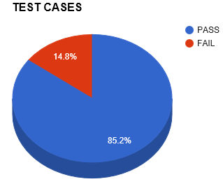

TEST CASE SUMMARY

|  |  |  |  |
| --- | --- | --- | --- |
| TEST CASES PLANNED | TEST CASES EXECUTED | TEST CASES PASSED | TEST CASES FAILED |
| 27 | 27 | 23 | 4 |

### DEFECTS

**Critical** - The defect affects critical functionality or critical data. It does not have a workaround. Example: Unsuccessful installation, complete failure of a feature.

**Major** - The defect affects major functionality or major data. It has a workaround but is not obvious and is difficult. Example: A feature is not functional from one module but

**Minor** - The defect affects minor functionality or non-critical data. It has an easy workaround. Example: A minor feature that is not functional in one module but the same task is easily doable from another module.

**Trivial** - The defect does not affect functionality or data. It does not even need a workaround. It does not impact productivity or efficiency. It is merely an inconvenience. Example: Petty layout discrepancies, spelling/grammatical errors.

|  |  |  |  |
| --- | --- | --- | --- |
| Test Case # | Date Executed | Description | Severity |
| 2-8 | 3/6 | Invalid Prices | MAJOR |
| 4-6 | 3/5 | Empty Staff Field | MINOR |
| 2-5 | 3/6 | Empty Staff Field | MINOR |
| 4-1 | 3/6 | Edit Transaction View | MINOR |

DEFECT REPORTS

|  |  |  |  |
| --- | --- | --- | --- |
| TEST CASE NUMBER | SEVERITY LEVEL | DESCRIPTION | STATUS |
| 2-8 | MAJOR | Invalid Prices | CLOSED |
| 2-5 | MINOR | Empty Staff Field | CLOSED |
| 4-1 | MINOR | Edit Transaction View | CLOSED |
| 4-6 | MINOR | Empty Staff Field | CLOSED |

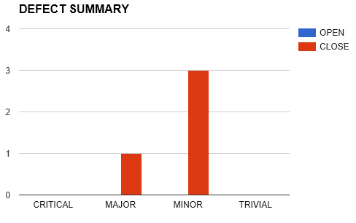

DEFECT SUMMARY

|  |  |  |  |  |  |
| --- | --- | --- | --- | --- | --- |
|  | CRITICAL | MAJOR | MINOR | TRIVIAL | TOTAL |
| CLOSED | 0 | 1 | 3 | 0 | 4 |
| OPEN | 0 | 0 | 0 | 0 | 0 |

# 

# ITERATION 1

|  |  |
| --- | --- |
| **User Stories** | **Iteration 1  Feb 16- March 8** |
| 1 - User Log In | PASS |
| 2 - Staff View In POS | PASS |
| 3 - Staff Record Transaction in POS | PASS |
| 4 - Staff Edit Transaction in POS | PASS |
| 5 - User Log Out | PASS |

# 